Project 2 – APPs

EECS 3421

F 2017

David Geller

214404255

**Description of Program**

The Search and Purchase program implements a unix command line application that prompts the user to enter their custID. After entering their ID they can pick a category in the database to search for a book in the database. When they have chosen the book they want to purchase the program finds the club that has the best price for the book and displays it. If the user still wishes to purchase the book they are prompted for the quantity and then give the final price before the purchase is inserted into the database. The program then exits. If the user no longer wishes to purchase the book the program exits.

**Tools used in this project**

* Db2 for SQL
* yrb_database for the database information
* Eclipse Oxygen for programming in java
* Javadoc for documentation in java
* Gyazo screen capture software

**How to Setup/Run Program**

1. Sign into a PRISM computer or login in remotely to red.cs.yorku.ca using your account.
2. Go to where SearchAndPurchase.java is located.
3. Prime the shell by writing “source ~db2leduc/cshrc.runtime” in the command line.
4. Compile by writing “javac SearchAndPurchase.java” in the command line.
5. Run by writing “java SearchAndPurchase” in the command line.
6. Program should be up and running!



**Program Walkthrough**

When the user first enters the program they are asked to present their customer ID. If the id is invalid they are asked to enter again until valid. When a valid customer ID is entered the program display the customer name and city and proceeds to the next prompt. 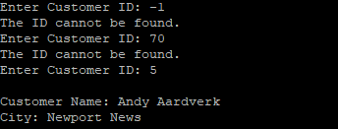

Next the customer is asked to choose from one of the following displayed categories. If the category doesn’t exist the customer is prompted to enter a valid category. Otherwise the program displays all the books in that category and proceeds to the next prompt.

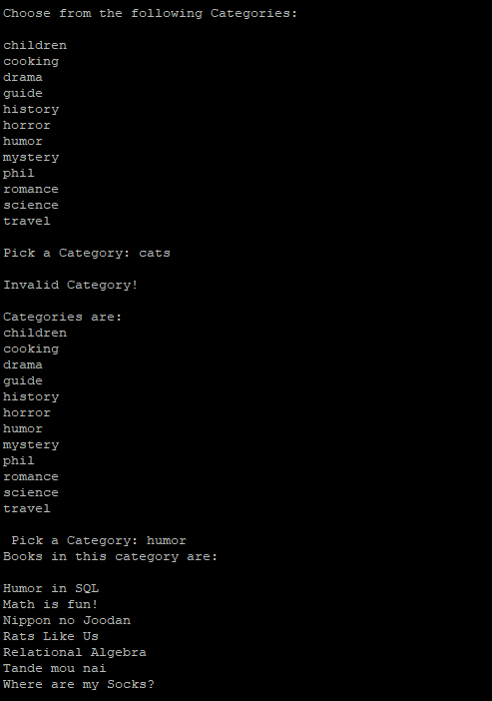

Next the customer is asked to pick a book from the category. If the book doesn’t exist the customer is prompted (as before) to pick a valid book. When a valid book is chosen the program displays all the books available with that title and displays the title, year, language and weight.

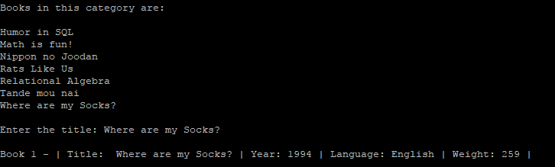

Next the user is asked to pick a book from this list. If book value entered is invalid the user is prompted to pick a valid book from the list. After a book is chosen the minimum price of the book is displayed. 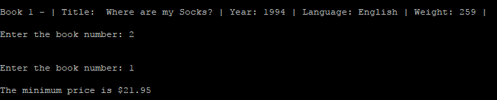

Next the user is asked if they want to purchase the book for this price. If the user says no then the program exits. Otherwise if the user says yes then they are prompted for the quantity of this book that they want to purchase. After a valid quantity is entered the book name is displayed with the club is was purchased from and the total price it was purchase for.

